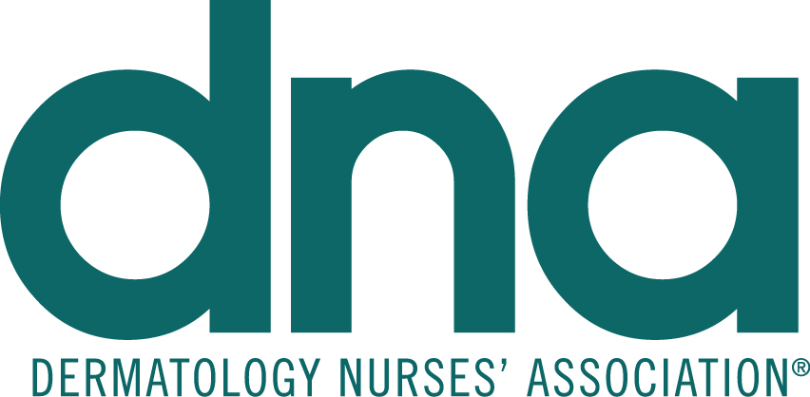
Application for Attendee Room Drop

YES, we would like to arrange for an Attendee Room Drop Piece during the DNA 2018 Annual Convention. Please note that your materials will not be returned and that we are not responsible for no-shows.

Name

Company:

Address:

City: State: Zip:

Phone: email:

Name: Title:

The cost is $4000 net (must be prepaid), quantity requested 600 pieces

Method of Payment: Check Enclosed Credit Card Visa Master Card AMEX

Name on Credit Card
Credit Card Number
Security Code Expiration Date
Charge Amount $
Credit Billing Address street # zip code
Signature
DNA Tax ID #22-2485816

February 5, 2018 is the deadline to participate in the DNA Room Drop Program. Return completed form to heidi.perret@ajj.com

All promotional materials must be no larger than 8 1/2" x 11", unless otherwise specified and must arrive no later than February 9, 2018. Send a sample of the flyer and shipping/tracking information to heidi.perret@ajj.com by February. 9, 2018.

Ship materials to:

TO: DNA Annual Convention Door Drop / Attn: Tom Greene
Sheraton San Diego Hotel & Marina
1380 Harbor Island Drive
San Diego, CA 92101

If paying via check, CHECKS must be sent to:
DNA Annual Convention
435 N. Bennett Street
Southern Pines, NC 28387-4814
Mail checks payable in U.S. Funds to DNA

